**Project Report**

**Auto street Light**



**Spring 2022**

**CS-I LAB Spring 2022**

**Saif-ur-Rehman** (**21PWCSE2001)**

**Zawar Ahmed khan (21PWCSE1989)**

Class Section: **C**

“On my honor, as student of University of Engineering and Technology, I have neither given nor received unauthorized assistance on this academic work.”

Submitted to:

**Engr. Faiz Ullah**

July 28, 2022

Department of Computer Systems Engineering

University of Engineering and Technology, Peshawar

**Introduction:**

It is a simple and powerful concept, which uses transistor (BC 547 NPN) as a switch to switch ON and OFF the street light system automatically. It automatically switches ON lights when the sunlight goes below the visible region of our eyes. (e.g in evening after Sunset). It automatically switches OFF lights when Sunlight fall on it (i.e on LDR) e.g in morning, by using a sensor called LDR (Light Dependent Resistor) which senses the light just like our eyes.

**Block Diagram:**

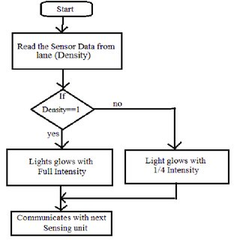

**Circuit Diagram:**

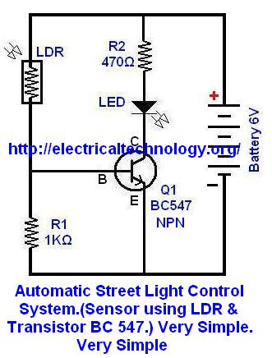

**Components:**

* Transistor (BC 547)
* Resistor (10k) ohm
* Battery
* LDR
* LED Bulb
* Jumping wire
* Breadboard

**Applications:**

* Can be used in home as a night lamp by using bulb of small wattage.
* As the name suggests this can be used in street lights where it is difficult to reach like mountaineous regions.

**Conclusion:**

* By employing this circuit, energy consumption can be reduced considerably as the Light switches ON or OFF automatically in appropriate time.
* Errors which occur due to manual operation can be eliminated completely.
* The construction of the circuit is also simple.

**\*\*\*\*\*\*\*\*\*\*\*\*\*\*\*\*\*\*\*\*\*\*\*\*\*\*\*\*\*\*\*\*\*\*\*\*\*\*\*\*\***